AI-BASED SMART CLASSROOM MONITORING
USING FACIAL RECOGNITION AND SENTIMENT ANALYSIS



Final Year Project Proposal
Bachelor of Science in Information Technology (BSc. IT)

Prepared by:
Uttam Chaudhary Shreejal Shrestha
Udhav Kharel Amit Mukhiya

Submitted to: Presidential Graduate School
Project Supervisor: Bibek Khanal
Submission Date: August 19, 2026

Abstract
This proposal presents an AI-Based Smart Classroom Monitoring and Attendance System that uses computer vision to identify enrolled students, record attendance, track students in a live classroom feed, analyze selected observable engagement indicators, and show authorized student information when a teacher clicks a recognized student. During an active class session, a camera will detect and track students while a pre-trained face-recognition model associates confident tracks with enrolled identities. The first valid recognition will create one attendance record for that student and session, with duplicate entries prevented. Face and pose landmarks will then be analyzed over short time windows for cues such as head direction, prolonged looking away, head-down posture, high movement, face visibility and a basic possible-drowsiness indicator. The system will not claim to determine internal emotions such as boredom. A teacher dashboard will show identity, attendance status and current indicators, while a clickable profile panel will provide approved academic information, attendance history and recent monitoring events. Evaluation will cover recognition, attendance correctness, tracking, indicator performance, speed, security and usability.
Keywords: smart classroom, attendance, computer vision, face recognition, multi-object tracking, engagement indicators, student monitoring

Table of Contents
Introduction 5
Literature Review 7
Aim and Objectives 9
Aim 9
Objectives 9
Methodology 11
Project Approach 11
Data Collection and Student Enrollment 11
Real-Time Identification, Tracking and Attendance 12
Observable Engagement Indicator Analysis 12
Interactive Live Feed and Student Profile 12
Application and Data Management 13
Timeline and Milestones 13
Expected Outcomes 15
Testing and Evaluation 16
Legal, Social and Ethical Issues 17
Legal Issues 17
Social Issues 17
Ethical Issues 17
Resource Requirement 18
References 19
Appendix 21
Appendix A: Proposed Functional Scope 21
Appendix B: Proposed Data Model 22
Appendix C: Planned Evaluation Conditions 22
Appendix D: Proposed Student Profile Information 23

Introduction
Attendance is an important part of academic monitoring and institutional reporting because it helps teachers and administrators keep track of student participation and maintain accurate academic records. However, traditional methods such as calling names, passing attendance sheets, or manually entering records can consume valuable teaching time and may introduce errors through missed names, duplicate entries, or incorrect recording. These methods can become even more difficult to manage in larger classrooms where teachers need to divide their attention between teaching and administrative tasks. Facial-recognition-based attendance systems provide a practical way to automate this repetitive process by identifying enrolled students and creating searchable digital attendance records with less manual effort (Rastogi et al., 2022).
The proposed project extends the concept of automatic attendance into a broader smart classroom monitoring system. In addition to recognizing enrolled students and marking each student present only once during an active class session, the system will continue tracking recognized students throughout the live classroom feed. It will analyze a limited set of observable behaviors such as prolonged looking away, head-down posture, high upper-body movement, temporary loss of face visibility, and possible drowsiness-related cues. The teacher will be able to view these indicators directly on the monitoring dashboard. An authorized teacher or administrator will also be able to click on a recognized student from the live feed and retrieve approved information such as the student's name, student ID, academic program, semester or section, attendance history, current attendance status, and recent monitoring events.

An important part of the proposed system is the distinction between observable behavior and psychological interpretation. Facial expressions and body movements do not provide a reliable one-to-one indication of a person's internal emotional state, meaning that behaviors such as looking away, moving frequently, or maintaining a neutral facial expression cannot prove that a student is bored, distracted, or disengaged (Barrett et al., 2019). For this reason, the system will not attempt to make definite judgments about students' emotions, personality, academic ability, or intentions. Instead, it will report descriptive indicators together with their duration or confidence so that teachers can use them only as supporting information. Human observation and judgment will therefore remain central to the final interpretation of classroom behavior.

Literature Review
OpenCV provides camera capture and real-time image-processing functions for the proposed vision pipeline (Bradski, 2000). Face localization and alignment can be supported by MTCNN, which combines face detection with facial landmark localization and is designed to handle pose and illumination variation (Zhang et al., 2016).
The identity module will use a pre-trained face-recognition model rather than train a deep network from scratch. ArcFace produces discriminative facial embeddings that can be compared with locally enrolled student representations (Deng et al., 2019). This is realistic for the project's limited dataset, hardware and six-month schedule.
Attendance requires more than recognition. A web-based university system by Ismail et al. (2022) showed how deep face recognition can be connected to stored features and attendance records. The proposed system adds active-session selection, first-recognition attendance marking, duplicate prevention and continued classroom tracking.
The monitoring component must preserve each student's temporary identity across frames. ByteTrack associates detections over time and helps reduce fragmented trajectories during movement or partial occlusion (Zhang et al., 2022). Stable tracking is necessary so attendance and monitoring events remain linked to the correct student.
Head pose can describe where a student is facing, although it cannot prove cognitive attention. Research has used head-pose information for attention understanding in human-computer interaction (Liu et al., 2021). The prototype will therefore estimate coarse directions and apply duration thresholds before recording an event.
Classroom engagement research suggests that multiple visual cues are more useful than relying on one facial expression. Hu et al. (2022) combined facial and upper-body information, while the Student Engagement Dataset demonstrates the value of realistic video annotations and evaluation conditions (Delgado et al., 2021). These findings support using head, pose and movement cues together.
Face-recognition errors can vary across people and conditions. NIST has documented demographic differentials in recognition performance (Grother et al., 2019). The system will therefore keep an unknown/low-confidence state instead of forcing every face to match an enrolled student, reducing the risk of incorrect attendance and wrongly attached monitoring events.
MediaPipe Face Landmarker and Pose Landmarker provide face and body landmarks from live video that can support head orientation, posture and movement analysis (Google, 2026). These tools allow the project to focus its experimentation on temporal logic, thresholds and system integration rather than training every visual component from the beginning.

Aim and Objectives

Aim
To design, implement and evaluate a computer-vision-based smart classroom monitoring and attendance system that automatically records recognized students' attendance, tracks them in a live classroom feed, summarizes selected observable engagement indicators and provides authorized click-to-view student information.

Objectives
The objectives translate the overall aim into practical and measurable stages of development. They are structured to move from responsible data preparation to student identification and tracking, automatic attendance recording, observable classroom-behavior analysis, and finally the development and evaluation of the teacher-facing application. Together, these objectives ensure that the project is not limited to building an AI recognition model; it also addresses the complete classroom workflow, including accurate attendance management, uncertainty handling, privacy-conscious monitoring, human review, and access to relevant student information. Each objective will therefore contribute directly to a testable component of the final prototype and will be evaluated during the six-month project period.
• Collect and preprocess a consent-based facial enrollment dataset and short annotated behavior-reference clips for approximately 20-30 student volunteers within the first two months.
• Develop a face-recognition and multi-person tracking pipeline that associates visible classroom tracks with enrolled student identities while retaining an unknown/low-confidence state.
• Implement automatic attendance recording for an active class session using the first valid student recognition, with timestamping, duplicate prevention and teacher review/manual correction.
• Implement observable monitoring indicators including coarse head direction, prolonged looking away, head-down posture, upper-body movement, face visibility and a basic possible-drowsiness cue using temporal thresholds.
• Develop and evaluate a secure teacher dashboard that overlays identity, attendance and monitoring indicators on the live feed and opens approved student information, attendance history and recent monitoring events when a recognized student is selected.

Methodology

Project Approach
The project will use iterative prototyping that combines an AI/ML workflow with web-application development. The first prototype will target one classroom, one camera and approximately 20-30 consenting students. Processing will run locally on a laptop or desktop rather than continuously sending classroom video to a public cloud. Git will be used for version control, and datasets, annotations and experiments will be documented separately.
Figure 1
Proposed Smart Classroom Monitoring and Attendance System Architecture
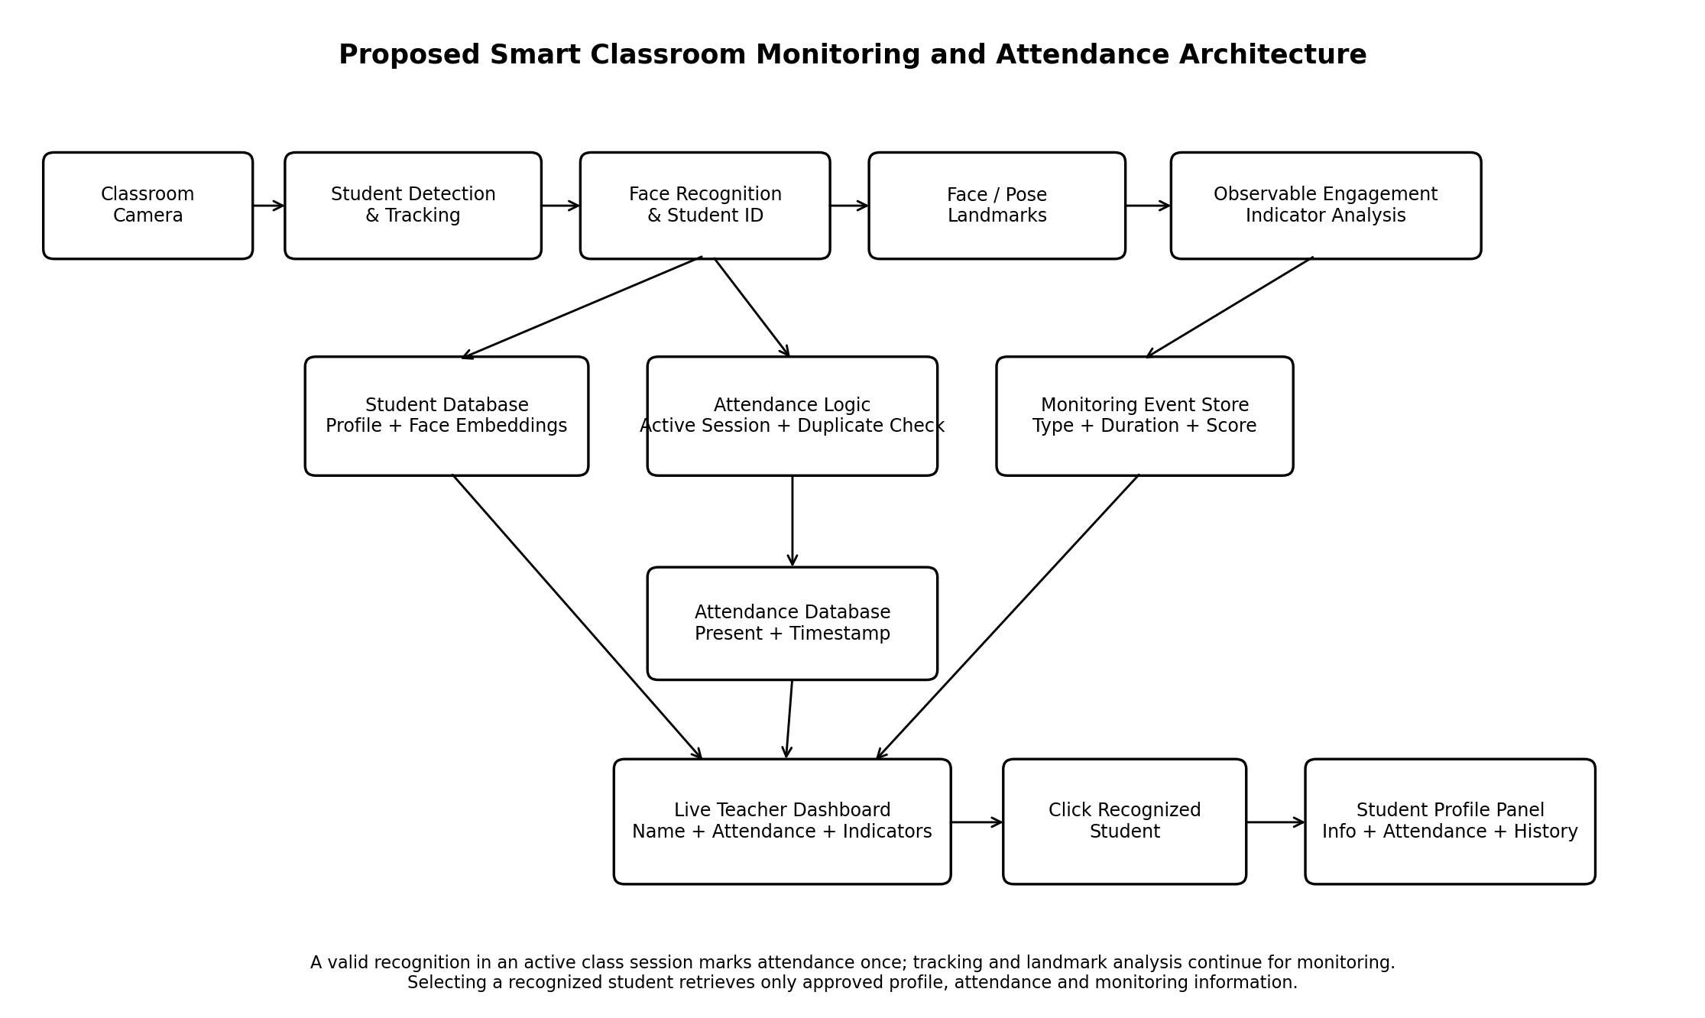

Data Collection and Student Enrollment
Student enrollment will collect several facial images for each consenting participant together with only the identity and academic fields needed by the prototype. Images will include modest pose and lighting variation. A pre-trained model will generate local face embeddings linked to an internal student ID. Short controlled reference clips will also be collected for visible conditions such as looking forward, looking away, head down, normal/high movement, temporary face loss and prolonged eye closure. These labels describe observable conditions rather than emotions.

Real-Time Identification, Tracking and Attendance
At the start of class, the teacher will select an active session and start the camera. A detector will locate visible students and a tracker such as ByteTrack will maintain temporary track IDs. Face recognition will associate a track with an enrolled student only above a selected confidence threshold; otherwise, it remains unknown. The first valid recognition will create an attendance record containing student ID, session ID, date/time and recognition confidence. The system will check for an existing student-session record before insertion so repeated detections cannot create duplicate attendance. Teachers can review or manually correct failures.

Observable Engagement Indicator Analysis
The monitoring module will analyze short temporal windows rather than label every frame. Face landmarks will support coarse head orientation and basic eye-related cues, while pose landmarks will support upper-body movement measurement. Example outputs are looking forward, looking away, head down, high movement, face not visible, possible drowsiness and no warning. A condition must persist for a configured duration before it becomes an event. The system will not output definitive labels such as bored, lazy or interested from facial appearance alone.

Interactive Live Feed and Student Profile
The live dashboard will show a bounding box, recognized name or unknown label, attendance status and a concise current indicator for each active track. When the teacher clicks a recognized student, the application will open a side panel with approved information such as name, student ID, program, semester/section, profile image, today's attendance status, attendance summary and recent monitoring events. Unrelated sensitive information will not be displayed.

Application and Data Management
A Django application will manage teacher/admin authentication, enrollment, class sessions, attendance, student profiles and monitoring events. SQLite will be used during development, with MySQL as an optional deployment database. Passwords will be hashed and access role-restricted. Core entities will include Student, Class/Session, Attendance and MonitoringEvent. Continuous raw classroom video will not be stored by default.

Timeline and Milestones
Months 1-2 cover literature review, requirements, consent/privacy preparation, enrollment and controlled reference data. Months 3-4 cover recognition, tracking, attendance logic, landmark analysis, threshold calibration, database development and dashboard integration. Months 5-6 cover integration, robustness, security and usability testing, deployment, documentation and presentation.

Figure 2
Proposed Six-Month Project Timeline
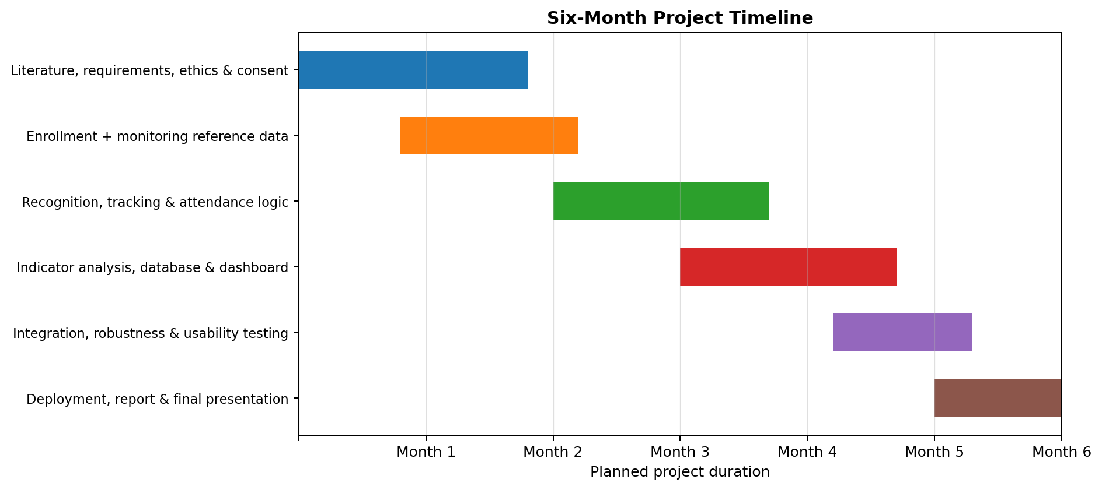

Expected Outcomes
The expected outcome of this project is a functional AI-based classroom monitoring and attendance prototype that can recognize enrolled students from a live classroom feed, automatically create one attendance record per student for a selected session, and continue tracking recognized students throughout the class. The system is also expected to display limited observable monitoring indicators such as looking away, head-down posture, high movement, face not visible, and possible drowsiness. These indicators will be presented as observations rather than definite conclusions about a student's emotions or level of engagement, and uncertain results will remain subject to teacher review.
The final prototype will also include an interactive teacher/admin dashboard where recognized students can be selected directly from the live feed to view approved information such as student ID, program, semester, attendance status, attendance history, and recent monitoring events. Major deliverables will include the enrollment, facial-recognition and tracking, attendance, monitoring, and dashboard modules; student, attendance, and monitoring-event databases; testing and evaluation results; documented source code; deployment instructions; and the final project report. Overall, the system is expected to reduce manual attendance work while providing teachers with organized classroom observations and student information in a privacy-conscious manner.

Testing and Evaluation
Evaluation will cover identity recognition, attendance correctness, tracking, monitoring indicators, software functions, security and usability. Face identification will use accuracy, precision, recall, F1-score, false acceptance rate and false rejection rate. Attendance tests will verify session selection, first-recognition marking, timestamping, duplicate prevention, unknown handling and manual correction against observed ground truth.
Tracking tests will measure continuity and identity switches during movement or partial occlusion. Monitoring indicators will be compared with manually labeled reference clips using precision, recall and F1-score for cases such as looking away, head down, high movement, face not visible and possible drowsiness. Tests will also vary lighting, head orientation, classroom distance and the number of visible students.
Initial targets are at least 90% face-identification accuracy in normal conditions, at least 98% correct duplicate-free attendance recording once a student is correctly recognized, F1-score of at least 0.80 for the main observable indicators, live processing of at least 8 frames per second on the target laptop and profile-panel opening within 1.5 seconds. These are evaluation targets, not guarantees. A small user test will assess whether teachers understand the dashboard without over-interpreting the indicators.

Legal, Social and Ethical Issues

Legal Issues
The project processes facial images, facial templates, attendance records and classroom video that may identify individuals. Nepal's Privacy Act, 2075 requires careful handling of personal information, so the project will use informed consent, purpose limitation, restricted access, controlled retention and a withdrawal/deletion process (Government of Nepal, 2018). Third-party model, software and dataset licenses will also be reviewed.

Social Issues
Classroom monitoring may make students feel watched or unfairly judged. Prototype participation will therefore be voluntary, monitoring will occur only during defined sessions and the interface will use descriptive indicators rather than labels that imply personality or misconduct. Manual attendance will remain available for participants who opt out or cannot be recognized reliably.

Ethical Issues
UNESCO emphasizes privacy, transparency, fairness and human oversight when AI affects learners (UNESCO, 2021). The prototype will disclose uncertainty, minimize stored data and prohibit automated disciplinary decisions. It will not infer age, ethnicity, personality, disability, emotion or academic ability from facial appearance. Teachers will be reminded that looking away, moving frequently or closing the eyes can have many explanations and are not proof of boredom or misconduct.

Resource Requirement
The project is designed around ordinary computing hardware and open-source software so that the prototype can be reproduced in a college environment.
Table 1
Proposed Resource Requirement
Resource Type | Requirement
Hardware | Laptop/desktop with a modern multi-core CPU and at least 8 GB RAM; 1080p webcam; optional NVIDIA GPU for faster experiments; local network for demonstration.
Software | Python, Django, OpenCV, MediaPipe, ArcFace-compatible face-recognition library, ByteTrack or equivalent tracker, MySQL, Git/GitHub and Jupyter Notebook.
Dataset | Primary consent-based student enrollment images and short controlled behavior-reference clips; public benchmark data only when licensing permits and only for background experiments.
Human Resources | Four project members, a supervisor and a small number of teacher/admin users for usability feedback.

References
Barrett, L. F., Adolphs, R., Marsella, S., Martinez, A. M., & Pollak, S. D. (2019). Emotional expressions reconsidered: Challenges to inferring emotion from human facial movements. Psychological Science in the Public Interest, 20(1), 1-68. https://doi.org/10.1177/1529100619832930
Bradski, G. (2000). The OpenCV library. Dr. Dobb's Journal of Software Tools, 25(11), 120-126.
Delgado, K., Origgi, J. M., Hasanpoor, T., Yu, H., Allessio, D., Arroyo, I., Lee, W., Betke, M., Woolf, B., & Bargal, S. A. (2021). Student engagement dataset. In Proceedings of the IEEE/CVF International Conference on Computer Vision Workshops (pp. 3628-3636).
Deng, J., Guo, J., Xue, N., & Zafeiriou, S. (2019). ArcFace: Additive angular margin loss for deep face recognition. In Proceedings of the IEEE/CVF Conference on Computer Vision and Pattern Recognition (pp. 4690-4699). https://doi.org/10.1109/CVPR.2019.00482
Google. (2026). MediaPipe Tasks: Face Landmarker and Pose Landmarker guides for Python. Google AI Edge. https://ai.google.dev/edge/mediapipe/solutions/vision
Government of Nepal. (2018). The Privacy Act, 2075 (2018). Nepal Law Commission. https://lawcommission.gov.np/content/12261/12261-the-privacy-act-2075/
Grother, P., Ngan, M., & Hanaoka, K. (2019). Face recognition vendor test part 3: Demographic effects (NISTIR 8280). National Institute of Standards and Technology. https://doi.org/10.6028/NIST.IR.8280
Hu, M., Wei, Y., Li, M., Yao, H., Deng, W., Tong, M., & Liu, Q. (2022). Bimodal learning engagement recognition from videos in the classroom. Sensors, 22(16), 5932. https://doi.org/10.3390/s22165932
Ismail, N. A., Chai, C. W., Samma, H., Salam, M. S., Hasan, L., Wahab, N. H. A., Mohamed, F., Leng, W. Y., & Rohani, M. F. (2022). Web-based university classroom attendance system based on deep learning face recognition. KSII Transactions on Internet and Information Systems, 16(2), 503-523. https://doi.org/10.3837/tiis.2022.02.008
Liu, H., Nie, H., Zhang, Z., & Li, Y. F. (2021). Anisotropic angle distribution learning for head pose estimation and attention understanding in human-computer interaction. Neurocomputing, 433, 310-322. https://doi.org/10.1016/j.neucom.2020.09.068
Rastogi, R., Tyagi, A., Upadhyay, H., & Singh, D. (2022). Algorithmic analysis of automatic attendance system using facial recognition: A revolutionary approach for future education. International Journal of Decision Support System Technology, 14(1), 1-19. https://doi.org/10.4018/IJDSST.286688
UNESCO. (2021). Recommendation on the ethics of artificial intelligence. https://www.unesco.org/en/legal-affairs/recommendation-ethics-artificial-intelligence
Zhang, K., Zhang, Z., Li, Z., & Qiao, Y. (2016). Joint face detection and alignment using multitask cascaded convolutional networks. IEEE Signal Processing Letters, 23(10), 1499-1503. https://doi.org/10.1109/LSP.2016.2603342
Zhang, Y., Sun, P., Jiang, Y., Yu, D., Weng, F., Yuan, Z., Luo, P., Liu, W., & Wang, X. (2022). ByteTrack: Multi-object tracking by associating every detection box. In Computer Vision - ECCV 2022 (pp. 1-21). Springer. https://doi.org/10.1007/978-3-031-20047-2_1

Appendix

Appendix A: Proposed Functional Scope
Module | Core Functions
User Management | Teacher/admin login, role-based access, password management and session authorization.
Student Enrollment | Student ID/name entry, consent confirmation, face capture, embedding generation and approved profile fields.
Attendance Session | Select class/session, recognize enrolled students, mark first valid recognition present, timestamp attendance, prevent duplicates and allow manual correction.
Live Monitoring | Detect students, maintain track IDs, recognize enrolled faces, preserve unknown state and display current observable indicators.
Engagement Indicators | Head direction, prolonged looking away, head down, upper-body movement, face visibility and a basic possible-drowsiness cue.
Student Profile Interaction | Click a recognized bounding box to open approved student information, current attendance, attendance history and recent monitoring events.
Privacy Controls | Restricted biometric storage, no continuous raw-video retention by default, withdrawal/deletion procedure and human oversight.

Appendix B: Proposed Data Model
• Student: student ID, name, program, semester/section, approved profile image and biometric embedding reference.
• Class/Session: session ID, course/class, teacher, date, start time and session status.
• Attendance: student ID, session ID, date/time, attendance status, recognition confidence and correction/audit note where applicable.
• MonitoringEvent: student ID, session ID, event type, start time, duration and confidence/quality score.

Appendix C: Planned Evaluation Conditions
• Lighting: normal classroom light, lower light and bright/backlit conditions.
• Pose and visibility: frontal view, modest left/right rotation, head-down posture and temporary face occlusion.
• Identity/attendance cases: enrolled student, unknown person, low-confidence match, repeated recognition, duplicate-prevention check and manual correction.
• Behavior cases: forward-facing, prolonged looking away, high movement, normal movement, face not visible and controlled prolonged eye closure.
• Interface cases: click recognized student, open profile, display approved information, attendance history and recent monitoring events.

Appendix D: Proposed Student Profile Information
Category | Displayed Information
Identity | Name, student ID and approved profile photograph.
Academic | Program, semester and section/class.
Attendance | Today's status, recognition time, attendance percentage and recent attendance history.
Current Session | Current observable indicator, tracking/recognition status and recent event timestamps.
Monitoring History | Recent monitoring-event summary for the selected session or permitted period.
Excluded by Default | Home address, family details, unrelated personal data, inferred personality, emotion, ethnicity, disability or academic ability.

